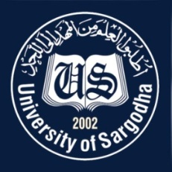 | Faculty Positions on Visiting Basis
Department of Statistics
University of Sargodha
Applications for the following positions are invited from Pakistani nationals for Fall Semester 2022.
Teaching Faculty

Sr.# | Positions | No. of Posts | Nature of Post | Eligibility Criteria
1. | Visiting Assistant Professors/Lecturers  Statistics | 20 | Visiting Faculty  (Open merit, for Fall Semester, 2022). | Qualification:-  - PhD in Statistics/BioStatistics for Assistant Professor  - M.Phil, in Statistics/ BioStatistics for Lecturer
NOTE |  |  | General Information
- As per university policy, department reserves the right not to consider any application or fill any post without giving any reason.
- Candidates are required to submit complete latest C.V, two latest Passport Size Pictures and attested copies of all testimonial documents along with duly filled application form in the Office of Department of STATISTICS, Sargodha University, Sargodha.
- Prescribed application form may be downloaded from university website (https://www.su.edu.pk/forms)
- Applications complete in all respects should reach the department on or before 12-09-2022.
- Demonstration / Interview of all candidates will be conducted on 14-09-2022 at 10:00 am in the office of Chairman, Department of Statistics, Sargodha University. No separate intimation will be given in this regard.
- The applicants having provisional transcript will not be eligible for the visiting faculty
- Applications received after due date will not be entertained.
- Candidates with relevant experience will be preferred.
- Online applications will not be accepted.
- Posts can be increased or decreased according to the requirement of subjects.
- No TA/DA will be admissible.

Dr. Hafiz Zafar Nazir

Chairman
Department of Statistics
University of Sargodha

